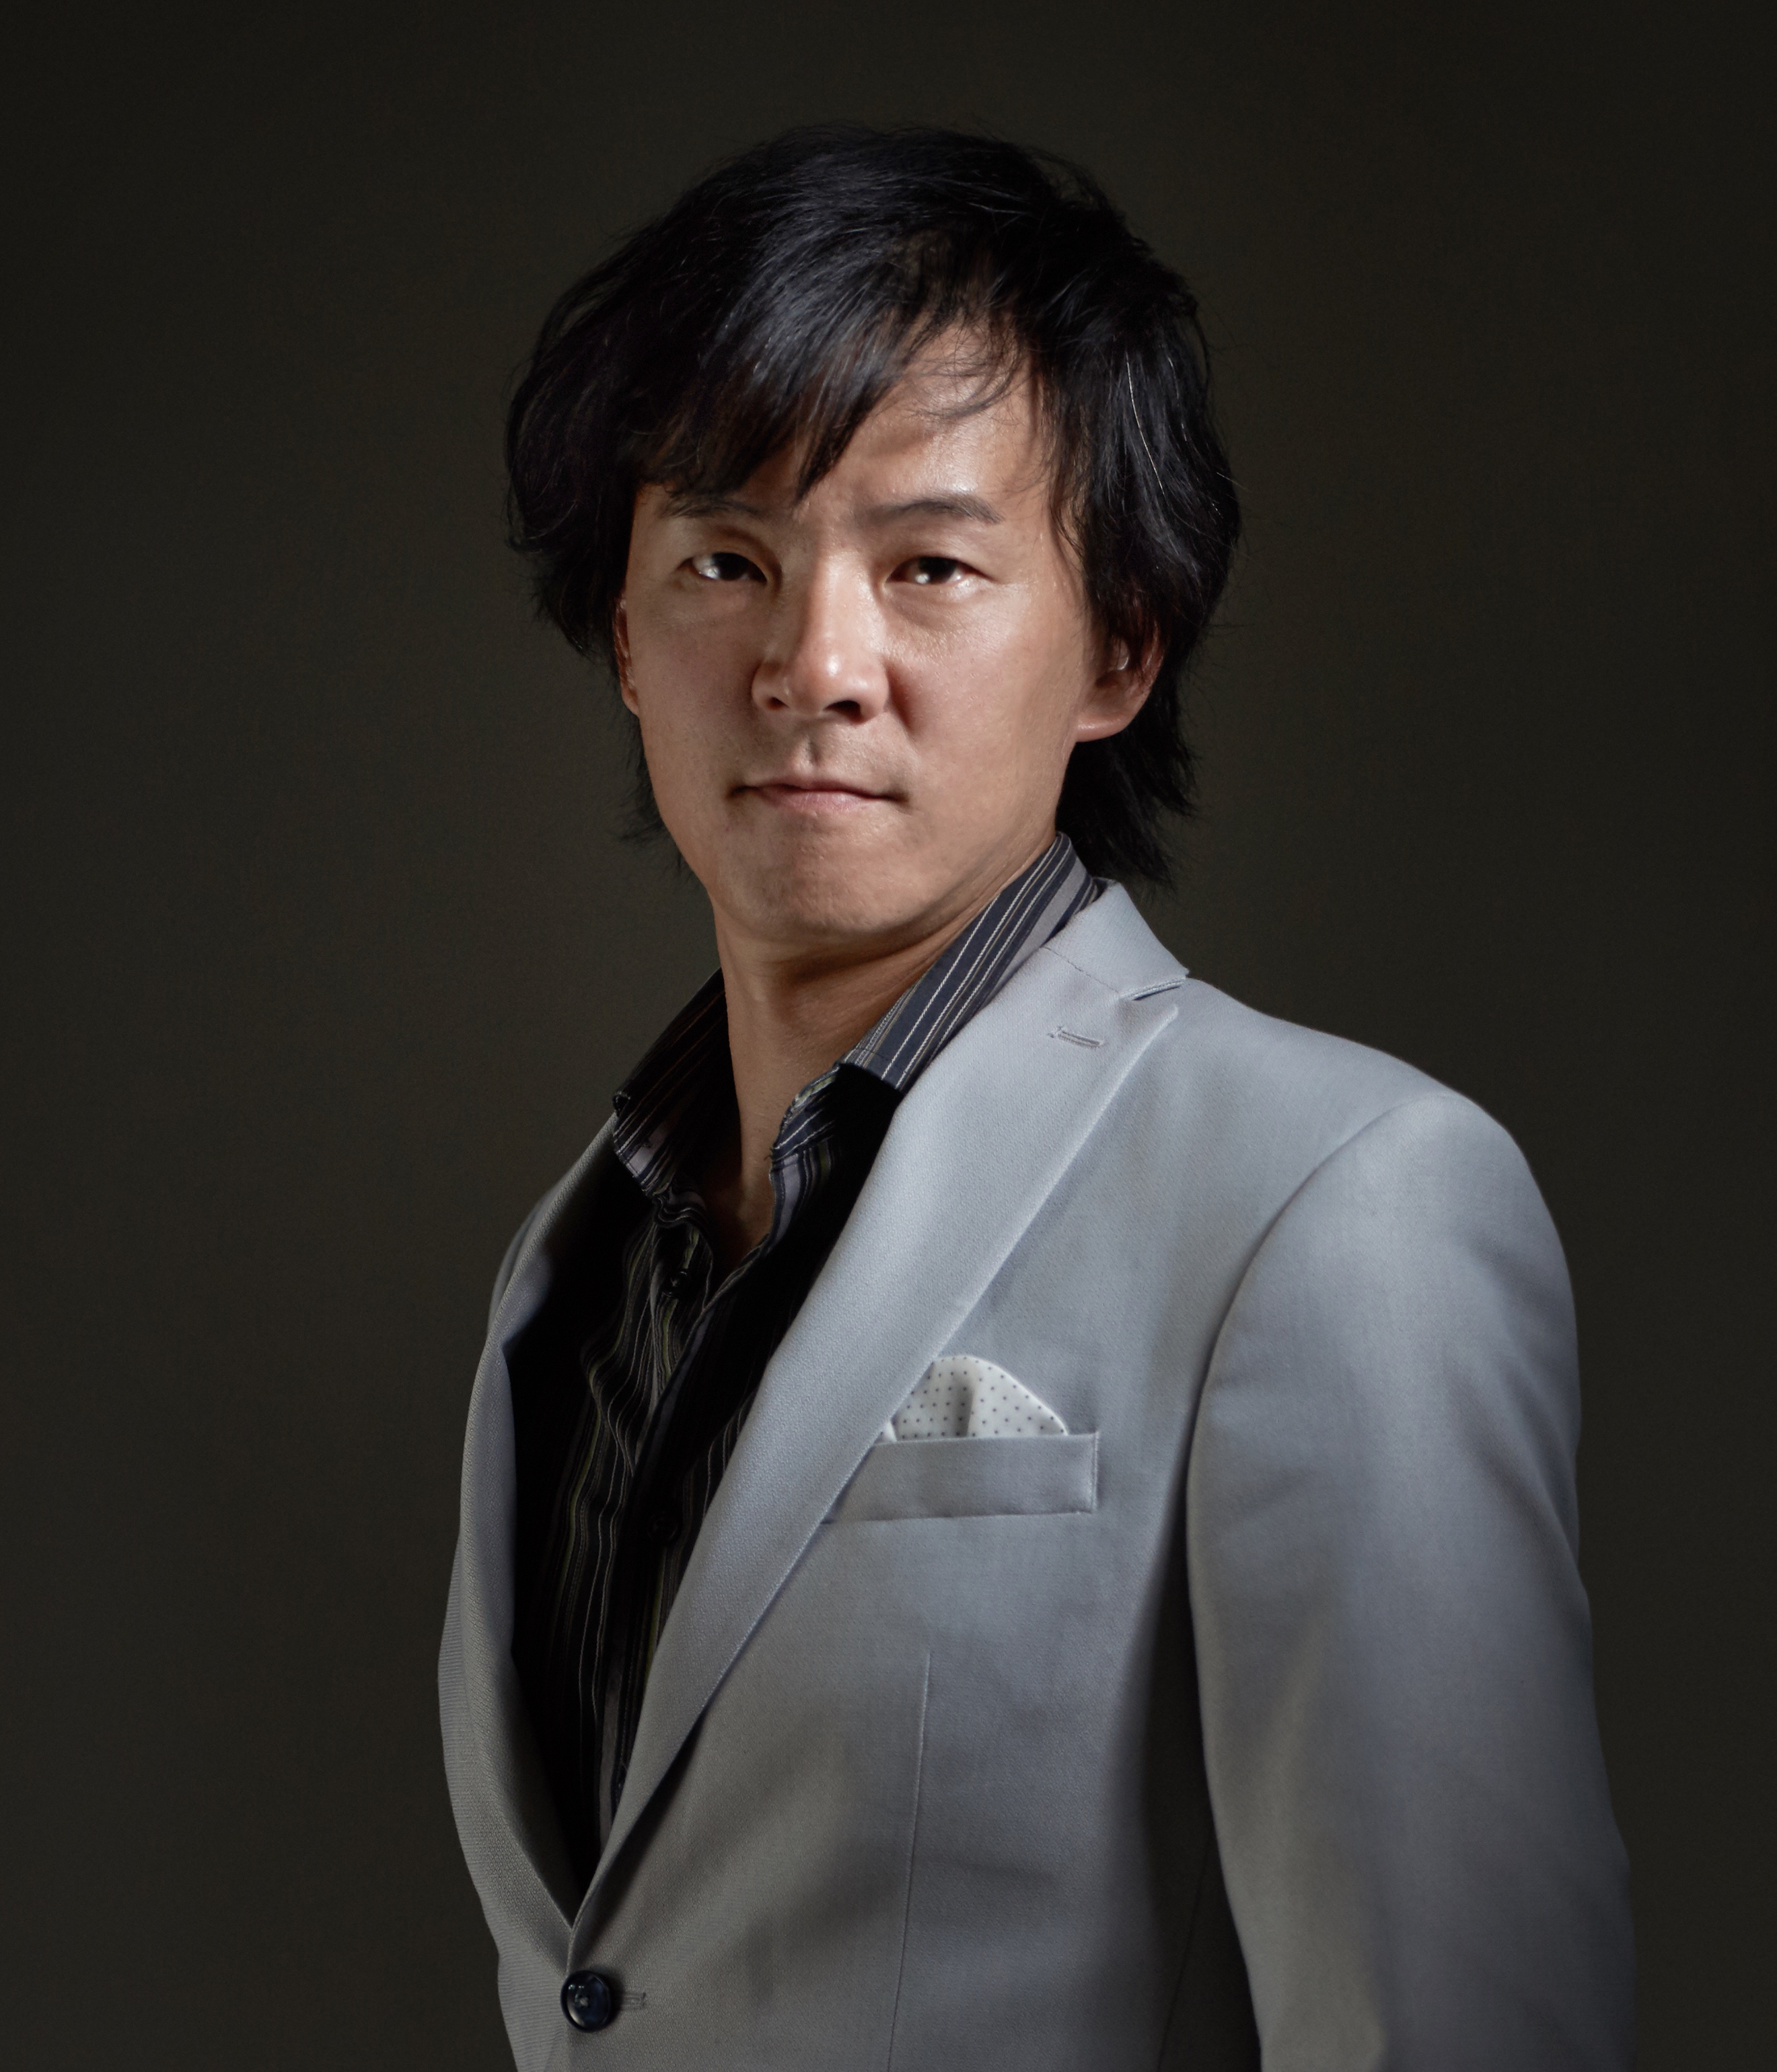

**Mr Tim Chou**

Tim Chou is the owner of Akuma Group, which includes Akuma Design, Akuma caca cafes and Akuma Living. He obtained a Master’s in Interior Design at the acclaimed Savannah College of Art and Design.

He is also an Associate Professor and Director of Design Centre of China University of Technology. He has received various awards such as the 2007 TID Awards, 2009 Taiwan Good Design, 2014Top 10 Best Designers in Dining Space Design of China, 2015 The Most Successful Design Award of China, 2015 The Most Influenced Designer in China, 2015 Red Dot Award, 2015 FX Interior Design Awards of UK, 2015 APIDA Award of Hong Kong, 2016 IF Design Award, 2017 GDA Award.